Special Interest Project
Cloud Computing
Project Title: ‘CloudEduTrack’: An Integrated Cloud-Based Quiz Examination System
Author: Yash Ananta Zode TeamName: CodeWithYash
Abstract:
CloudEduTrack is an innovative online quiz system tailored for users with motor and visual impairments, providing a voice-activated interface for enhanced accessibility. It features a customizable user interface with adaptable themes and text sizes, alongside voice-guided interactions for a responsive quiz experience. The platform's advanced voice recognition and synthesis capabilities allow users to seamlessly navigate quizzes and adjust the voice model's pitch and rate, ensuring an inclusive, user-friendly learning environment.
Architecture:

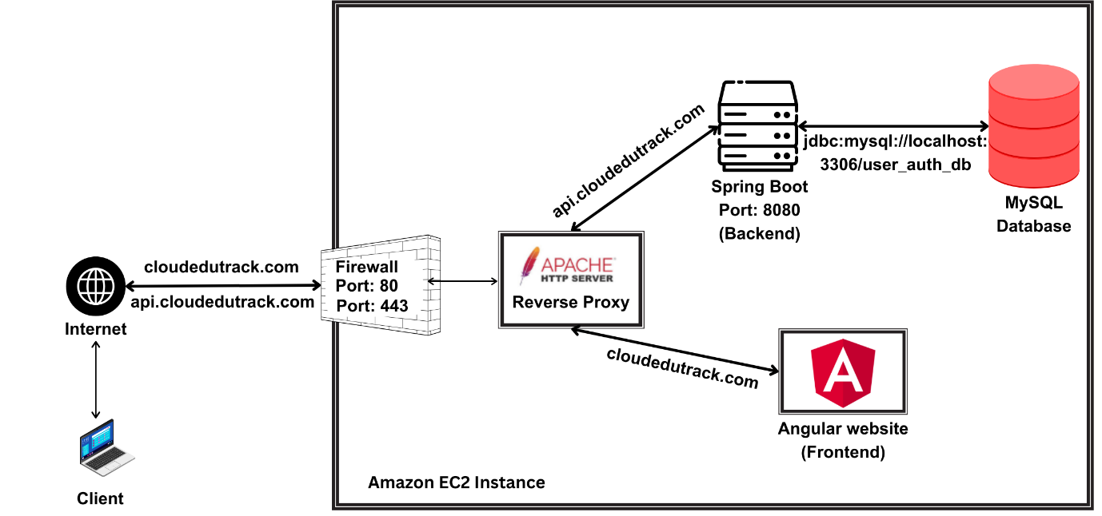

The website is hosted under the primary domain cloudedutrack.com, with a dedicated API subdomain at api.cloudedutrack.com.
The platform's infrastructure is consolidated on a single Linux server [running on AWS], where both the frontend and backend operate in harmony. Apache serves as the web server, configured to distinguish between requests for the website and API calls. Requests to the root domain deliver the Angular website files, while api.cloudedutrack.com redirects to the backend services running on localhost:8080. The backend, accessible via the subdomain api.cloudedutrack.com, utilizes this MySQL database for data storage and management.
Features:
CloudEduTrack is distinguished by its rich features tailored for accessibility.
Following are the features offered by CloudEduTrack:
- Voice-Activated Interface: The application incorporates a voice-activated interface for hands-free control and navigation, thereby enhancing accessibility and usability for individuals with motor and visual impairments.
- Customizable Themes: Users can alter the visual theme of the application via voice commands, allowing for a personalized interface that caters to individual visual preferences.
- Resizable Text: The application enables text resizing through voice commands, aiding users with visual impairments in achieving optimal readability.
- Voice-Guided Quizzes: The platform not only allows users to navigate and respond to quizzes using voice input but also includes a feature that reads out the questions and all associated options aloud.
- Detect Tab switches during quiz: System will automatically detect and store the number of times the user switched tab during the examination.
How it works:
CloudEduTrack's web interface is built using Angular, ensuring a dynamic and responsive user experience. It integrates specialized services such as voice recognition and synthesis, allowing for seamless interaction and accessibility across all pages.
The voice recognition service contains all functions that has to be triggered when the user says a voice command (for eg: ‘switch Theme’, ‘show next question’, ‘select option A’) and voice synthesis service contains features for changing voice model, customising pitch and rate of voice model.
Both Voice recognition and voice synthesis service uses Web Speech API [1].
The Web Speech API enables you to incorporate voice data into web apps. The Web Speech API has two parts: SpeechSynthesis (Text-to-Speech) [2], and SpeechRecognition (Asynchronous Speech Recognition.) [3], the integration of Web Speech API enabled this project to be voice-activated for hands-free control and navigation
Following is the image of Dashboard:
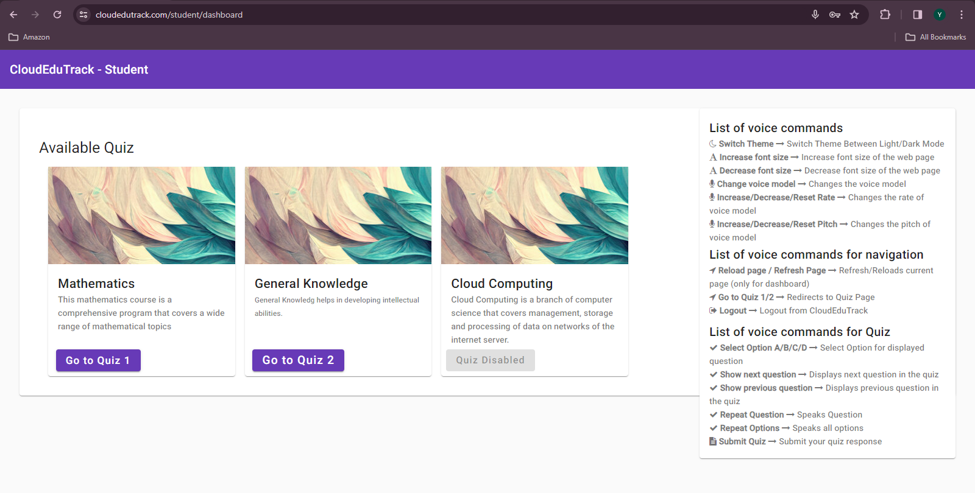
Following are the images of Speech Recognition and Speech Synthesis file
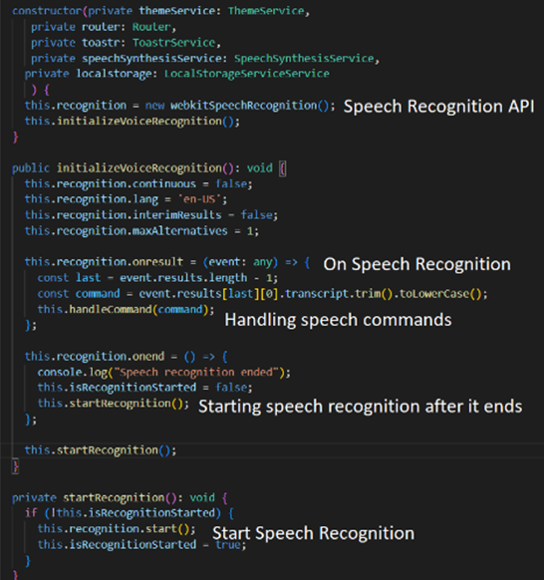
Fig: Speech Recognition service file
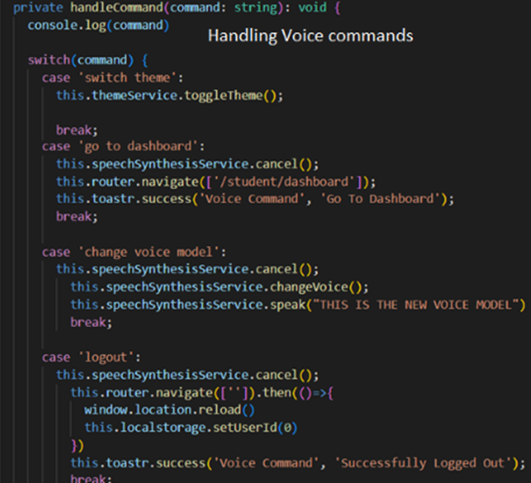
Fig: Speech Recognition service file
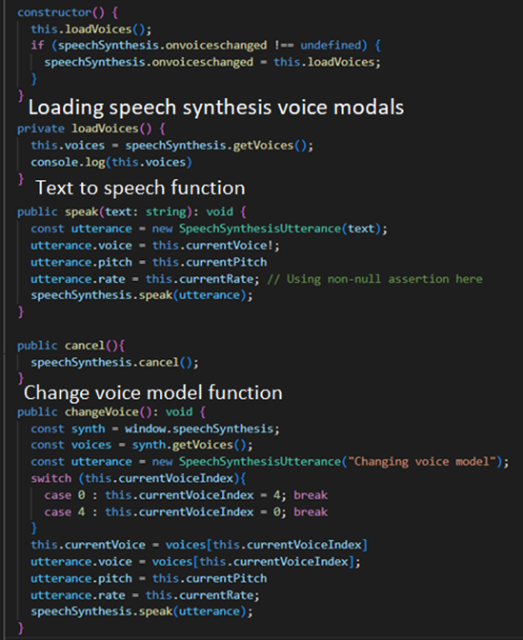
Fig: Speech Synthesis Service file (text-to-speech)
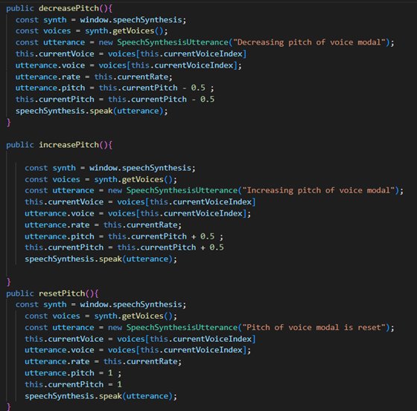
Fig: Speech Synthesis Service file (text-to-speech)
Following are the images of Apache Configuration Files, Backend Service File and Firewall Configuration:
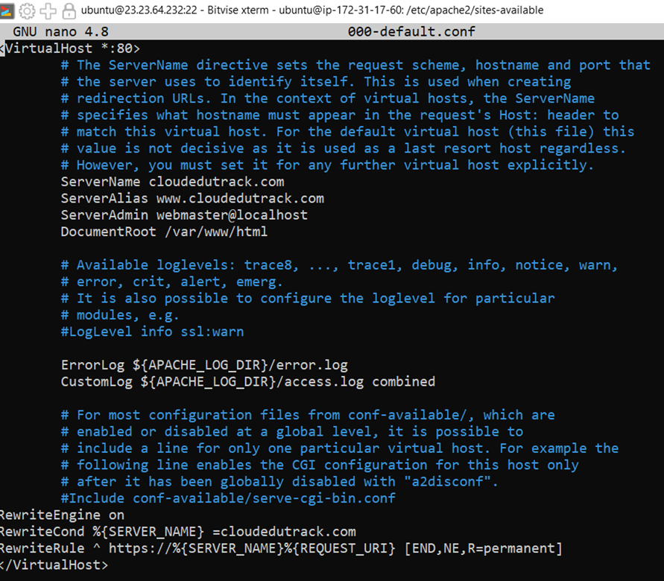
Fig: Apache Configuration File(000-default.conf)
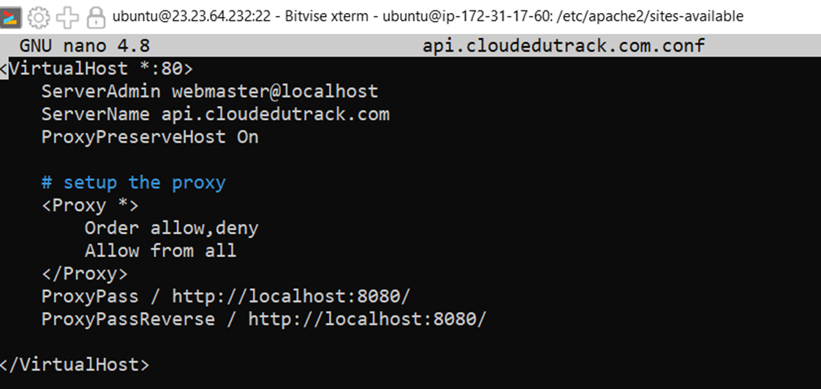
Fig: Apache Configuration File (api.cloudedutrack.com.conf)
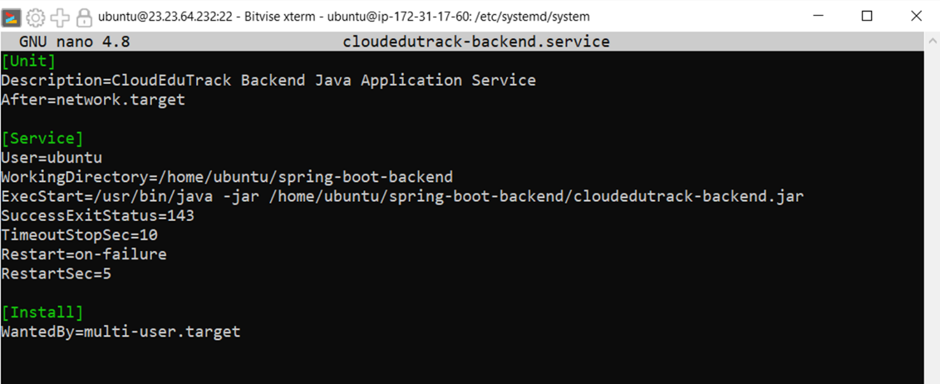
Fig: Backend service file

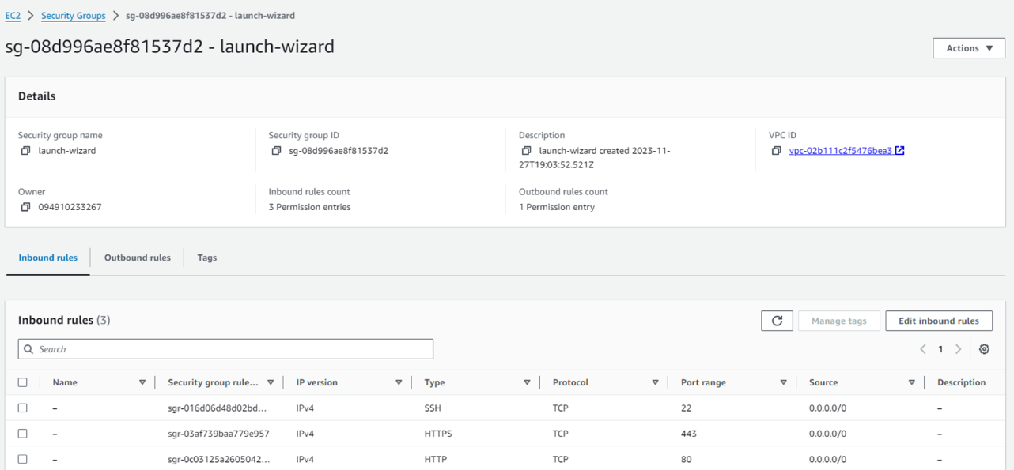
Fig: Firewall configuration of EC2 instance (AWS)
Try It Yourself:
To experience CloudEduTrack :
- Launch Chrome and navigate to www.cloudedutrack.com or https://cloudedutrack.com/
- Log in with the username and password provided. Start with user35 for both fields.
- Once logged in, you'll find a list of voice commands on the right. Begin exploring the system's features.
Note: Username and Password is same. If an account has already attempted the quiz, simply increment the username and password by one (e.g., user35, user36... and so on). There are 20 accounts available for trial purposes.
Github link: https://github.com/YashZode/CloudEduTrack
References:
[1] Web Speech API: https://developer.mozilla.org/en-US/docs/Web/API/Web_Speech_API
[2] Speech Synthesis: https://developer.mozilla.org/en-US/docs/Web/API/SpeechSynthesis
[3] Speech Recognition: https://developer.mozilla.org/en-US/docs/Web/API/SpeechRecognition

